**Types of Automobile Chassis Layout** (Page 01 to 06)

**Aim :** **Study of Chassis Frame Layout**

1) Introduction of chassis frame

2) Layout of chassis and its main components

3) Functions of the chassis frame

4) Types of chassis frame

5) Various loads acting on the chassis frame

6) Different bodies used in Automobiles

7) Requirement of bodies for various types of vehicles.

**Objective :**

• Requirement of chassis frame

• Types of Chassis frame

• Loads acting on chassis frame

• Layout of Automobile chassis and Layout of Drive.

• Different types of automobile bodies

**Theory :**

**1) Introduction of Chassis Frame :** Introduction of Chassis Frame: Chassis is a French term and was initially used to denote the frame parts or Basic Structure of the vehicle. It is the back bone of the vehicle. A vehicle with out body is called Chassis. The components of the vehicle like Power plant, Transmission System, Axles, Wheels and Tyres, Suspension, Controlling Systems like Braking, Steering etc., and also electrical system parts are mounted on the Chassis frame. It is the main mounting for all the components including the body. So it is also called as Carrying Unit.

**2) Layout of Chassis and its main Components :**

“Chassis” a French term which means the complete Automobiles without Body and it includes all the systems like power plant, transmission, steering, suspension , wheels tyres , auto electric system etc. without body. If Body is also attached to it them it is known as the particular vehicle as per the shape and design of the body.

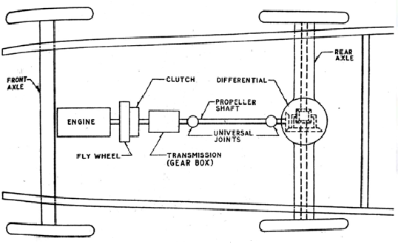

**Components of Automobile Chassis Layout :**

**Basic Structure** – This is the unit on which are to be built the remainder of the units to turn it in to a power operated vehicle. It consist of frame, suspension system, axles, wheels and tyres.

**Frame –** There are two distinct forms of construction

1. The conventional pressed steel frame to which all the mechanical units are attached and on

which the body is superimposed.

2. The integral or frameless construction, in which the body structure is so designed as to combine the functions of body and frame, the units normally attached to the frame being attached directly to the body. Frameless construction is possible only in case of a closed car, since the roof, screen pillars, door pillars and rear panel are essential load taking parts of structure.

**Suspension System** – Functions of suspension systems are

1. To prevent the road shocks from being transmitted to the vehicle components

2. To safeguard the occupants from road shocks

3. To preserve the stability of the vehicle in pitching or rolling, while in motion

There are two types of suspension systems

1. **The conventional system**, in which the springs are attached to a rigid beam axle

2. **The independent system,** in which there is no rigid axle beam and each wheel, is free to move

vertically without any reaction on the other wheel.

**Axles** – The weight carrying portions of the axles , whether it may be front or rear ,may be considered as beam supported at the ends , loaded at two intermediate points and subjected to following loads

1. The vertical load at the spring centers due to which the weight of the vehicle.

2. A fore and aft load at the wheel centre due to driving or braking effort

3. Torque reactions due to the drive or brakes.

4. A side thrust at the radius of the tyre due to centrifugal force when rounding a curve.

**Wheels** – Wire spoked wheels have been used mainly on sports cars, primarily on account of their light weight and quickness in changing the wheel .However the pressed steel wheel has displaced these all ordinary purposes. Such a wheel consist of a central flanged disc pressed in to a rolled section rim retained I n position by welding. Light alloy wheels are currently used in case of luxury and sport cars.

**Engine** – Engine provides the motive power for all the various functions which the vehicle or any part of it, may be called upon to perform. Engine generally consists of an internal combustion engine which may be either of spark-ignition, or of compression ignition type.

**Transmission System** –

Functions of transmission system are

1) To disconnect the engine from the road wheels when desired

2) To connect the engine to driving wheels without shock

3) To vary the leverage between the engine and the driving wheels

4) To reduce the speed permanently in a fixed ratio

5) To turn drive through a right angle

6) To make a provision such that the driving wheels may rotate at different speeds while taking turns.

**Clutch** – Its purpose is to enable the driver to disconnect the drive from the road wheels instantaneously and to engage drive from the engine to the road wheels gradually while moving the vehicle from rest. Gear Box (Transmission) – The gear box or transmission provides the necessary leverage variation between the engine and road wheels.

**Gear Box (Transmission)** – The gear box or transmission provides the necessary leverage variation

between the engine and road wheels.

**Propeller Shaft**  : The propeller shaft also called the drive shaft is a component of the drive train in a vehicle, with the purpose of delivering torque from the transmission to the differential, which then transmits this torque to the wheels in order to move the vehicle.

**Universal joint-** They provide for the relative movement between the engine and the driving wheels due to flexing of road springs.

**Differential –** While taking turns, the driving wheels must run at different speeds. This is done with the help of differential. Instead of using the long propeller shafts and transmitting the power from engine to the rear axle , a number of alternative methods have been used.

**The Functions of the Chassis frame :**

1. To carry all the stationary loads attached to it and loads of passenger and cargo carried in it .

2. To withstand torsional vibration caused by the movement of the vehicle

3. To withstand the centrifugal force caused by cornering of the vehicle

4. To control the vibration caused by the running of the vehicle

5. To withstand bending stresses due to rise and fall of the front and rear axles.

**Types of Chassis frame :**

**There are three types of frames**

**1. Conventional frame :**

**2. Integral frame :**

**3. Semi-integral frame :**

**1. Conventional frame:** It has two long side members and 5 to 6 cross members joined together with the help of rivets and bolts. The frame sections are used generally.

There are different types of chassis frame sections



**1. Channel section**  **2. Box section**  **3. Tubular section**

1. **Channel Section** - Good resistance to bending

2**. Box Section -** Good resistance to both bending and Torsion

3. **Tabular Section** - Good resistance to Torsion

**2. Integral Frame:** This frame is used now a days in most of the cars. There is no frame and all the assembly units are attached to the body. All the functions of the frame carried out by the body itself. Due to elimination of long frame it is cheaper and due to less weight most economical also. Only disadvantage is repairing is difficult.

**3. Semi - Integral Frame:** In some vehicles half frame is fixed in the front end on which engine gear box and front suspension is mounted. It has the advantage when the vehicle is met with accident the front frame can be taken easily to replace the damaged chassis frame. This type of frame is used in FIAT cars and some of the European and American cars.

**Various loads acting on the Chassis frame are :**

**1. Short duration Load -** While crossing a broken patch.

**2. Momentary duration Load -** While taking a curve.

**3. Impact Loads -** Due to the collision of the vehicle.

**4. Inertia Load -** While applying brakes.

**5. Static Loads -** Loads due to chassis parts.

**6. Over Loads -** Beyond Design capacity.

**Different Bodies used in Automobiles :**

The automobiles bodies are designed according to the requirement of the vehicle. According to design and requirement of the vehicle , there are different types of Automobiles bodies. Some of them are listed as below :

|  |  |  |  |
| --- | --- | --- | --- |
| **Car** |  | **Long Truck Trailer** |  |
| **Truck Straight** |  | **Tanker** |  |
| **Truck Half Body** |  | **Dumper** |  |
| **Truck Flat form Type** |  | **Delivery**  **Van** |  |
| **Tractor** |  | **Jeep** |  |

* **According to Chassis design the body can divided into**

1. Conventional Type

2. Integral Type

3. Semi- Integral Type

* **According to other usage:**

1. Light vehicle Bodies - cars, jeeps

2. Heavy vehicle Bodies – Busses, Lorries

3. Medium vehicle Bodies - Vans, Metadoors

**REQUIREMENTS OF BODIES FOR VARIOUS TYPES OF VECHILE:**

**The body of the most vehicle should fulfill the following requirements:**

1. The body should be light.

2. It should have minimum number of components.

3. It should provide sufficient space for passengers and luggage.

4. It should withstand vibrations while in motion.

5. It should offer minimum resistance to air.

6. It should be cheap and easy in manufacturing.

7. It should be attractive in shape and colour.

8. It should have uniformly distributed load.

9. It should have long fatigue life

10. It should provide good vision and ventilation.

**Types of Automobile Drive Layout** (Page 06 to 16)

The vehicle is based upon type of drive used. They are front Engine Rear Wheel Drive, Rear Engine Rear Wheel Drive, Front Engine Front Wheel Drive and Four Wheel Drive, which are discussed below ,

**1. Front Engine Rear Wheel Drive :**

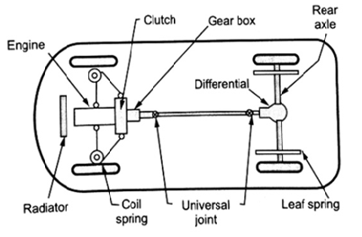Rear wheel drive places the engine in the front of the vehicle and the driven wheels are located at the rear, a configuration known as front-engine, rear-wheel drive layout. In this layout a front mounted engine-clutch-gear box unit drives a beam type rear axle supported on leaf springs through a propeller shaft with two universal joints. With the help of coil springs, the front Wheels are independently sprung.

**Fig. 1A - Front Engine Rear Wheel Drive**

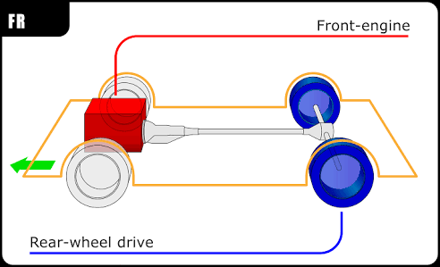

**Fig. 1B - Front Engine Rear Wheel Drive**

This layout is one of the oldest layout which remains unchanged for many years.

Some of the advantages provided by this system are :

(a) Even weight distribution: Balanced weight distribution between the front and the rear wheels providing good handling characteristics.

(b) For easy front wheel steering movement enàne occupies the reduced width between the wheel arches.

(c) Large luggage space is provided behind the rear seat.

(d) Maintenance and accessibility of engine, gear box is easy and the control over the accelerator, clutch, choke simple.

(e) Radiator cooling is natural (by air) so decreases the power required for cooling.

(f) Better braking efficiency : The more even weight distribution helps prevent lockup from wheels becoming unloaded under Disadvantages

**Disadvantages :**

1. Reduces back seats leg room space,

2. A tunnel is needed for the propeller shaft,

3. Reduces boot space,

4. Heavier and more expensive.

5. If stuck in mud or snow it is harder to drive away than in a front wheel drive car .

**2. Rear Engine Rear Wheel Drive :**

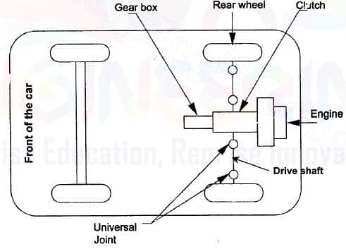This layout consists of placing the engine, clutch and gearbox in the back. So taking the space of the boot. In these type of layout more than 50% of the weight is on the rear axle. The necessity of the propeller shaft is completely eliminated. The clutch, gear box and engine and final drive form a single unit.

**Fig. 2A - Rear Engine Rear Wheel Drive**

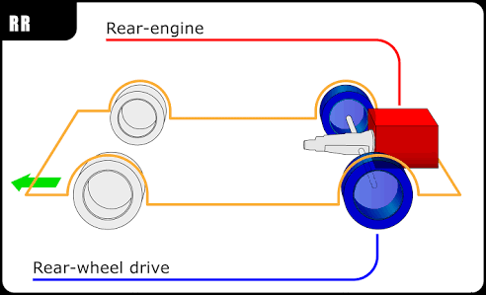

**Fig. 2B - Rear Engine Rear Wheel Drive**

**Advantages :**

1. Excellent traction is available while climbing hills.

2. A larger passenger space is available for the given length of body.

3. Very compact and accessible power and transmission assembly is provided.

4. Lot of weight at the back improves acceleration and braking, rear wheels and disc brakes can be designed to take a bigger amount of braking due to the weight distribution to the rear end.

5. Passengers are comfortable from engine noise, heat and fumes.

6. Front of the vehicle provides good visibility and by designing the body to aerodynamic shape gives good streaming lining.

**Disadvantages :**

1. At high speed, relatively high proportions of weight at the rear axle will make the car unstable at speed. There is a strong tendency for the vehicle to oversteer.

2. The space at the front has to be reduced to allow for the steering lock of the front wheel.

3. Space utilized for engine compartment is wasted.

4. Difficulties with the arrangement of the engine cooling system. Natural cooling of radiator is not possible. Power requirement increases. Compact engine, clutch and gearbox make servicing more difficult.

5. The wheels gets turn too sharply due to tendency of the vehicle to over steer. This necessitates the turning of the steering wheel in the opposite direction to make the correction by driver.

**3) Front Engine Front Wheel Drive :**

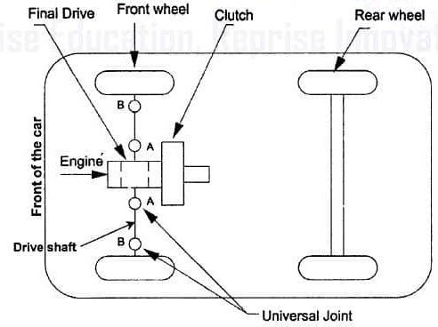 This type of arrangement provides optimum passenger space and a flat floor line resulting in a transverse under floor-longitudinal engine position. The propeller shaft length is reduced or neglects the propeller shaft Good grip with road surface due to engine weight at front. Power required for the cooling is reduced. When the vehicle is to be ‘steer in’ to the curve, it provide ‘under-steer’ characteristics, which is always preferred.

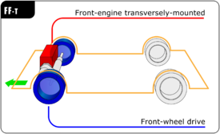**Fig. 03-A - Front Engine Front Wheel Drive**

**Fig. 03-B - Front Engine Front Wheel Drive**

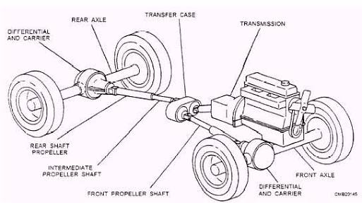**4. Four Wheel Drive / All Wheel Drive** : In this arrangement all the four wheels of the vehicle are driven by the engine thus making the entire vehicle weight available for traction. These four wheel drive vehicles are very useful on Hill station if one of the wheel slipping or skidding then the other axle wheel transmit the tractive force to the vehicle. The steering of the four wheel drive is hard to operate compared with other type of drive.

When the engine power is distributed to all wheels the vehicle is all-wheel drive (AWD) or four-wheel drive (4WD). There is no clear distinction between AWD and 4WD, but usually 4WD vehicles contain a transfer case, which has a central differential and an optional two-gear reductor (LO-low and HI-high). In case of an AWD or 4WD vehicle, both front and rear axles need to be equipped with a differential, due to the fact that all wheels transmit power and they need to rotate with different speeds during vehicle cornering. AWD/4WD vehicles are also called “four-by-four” (4×4) vehicles.

The numbers come from the vehicle **Driveline Formula**: 0**2 Total Number of Axles x 02 Total Number of Drive Axles.** For a vehicle with two axles, if only one axle has the drive wheels, the formula becomes “4×2“. If both axles have the drive wheels, the formula is “4×4“.

A permanent/full-time all-wheel drive vehicle has a permanent torque split between the front and rear axle, it cannot be disabled by the driver or by an electronic control module (ECM). An All Wheel Drive /4 Wheel Drive vehicle can have a 2 Wheel Drive mode because the ECM (or the driver) can disconnect one of the axles from being driven. In modern vehicles, the switch between 2 Wheel Drive and 4 Wheel Drive mode is usually done without the driver noticing.

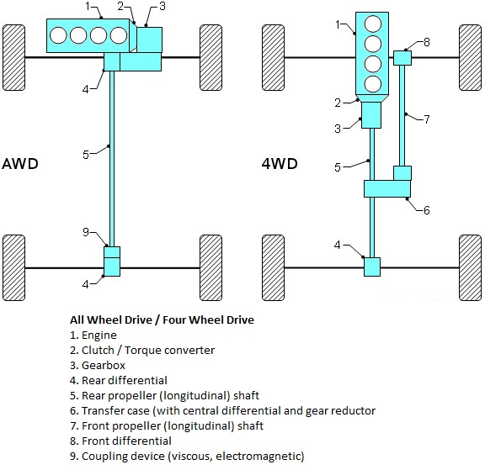

**Advantages :**

1. Traction is nearly doubled compared to a two-wheel drive layout.

2.Handling characteristics in normal conditions can be configured to emulate or R WD.

3. Gives sufficient power, this results in unparalleled acceleration and drivability on surfaces with less than ideal and superior engine braking on loose surfaces.

**Disadvantages : -**

1. The manufacturing cost of the vehicle is high.

2. More component and complicate transmission.

3. Increased power-train mass, rotational inertia and power transmission losses.

4. Increased fuel consumption compared to 2WD.

**(A) Rear Engine, All Wheel Drive (4WD) :**  Similar Characteristics As Rear Engine, Rear Wheel Drive and Other Additional As:

**Advantages :** 1. Better weight distribution. , 2. More neutral reactions. , 3. Better traction on bends and slippery road surfaces.

**Disadvantages:** 1. Heavier. , 2. More expensive and difficult to design and build.

**(B) Front Engine, All Wheel Drive (4WD) :** Similar characteristics as the front engine, rear wheel drive Plus .

**Advantages :** 1. Better handling capacity. , 2. Better acceleration.

**Disadvantages :** 1. It increases weight and manufacturing cost compare with front engine layouts.

2. Loss of some space in the back seats legs room.

**Differentiate Between Front and Rear Mount Engine Vehicle :**

|  |  |
| --- | --- |
| **Front Mount Engine Vehicle** | **Rear Mount Engine Vehicle** |
| Travelling is faster and safer as compare to rear mount engine. | Travelling is less faster and safer than front mount engine. |
| These engine vehicles have good road adhesion due to large vehicle weight carrying on driving wheel. | This engine vehicles having less road adhesion as compared to front mount engine |
| This engine provide less passenger comfort compared to rear mount engine. | This engine provides better passenger comfort due to reduce noise, heat and fumes. |
| It provides high floor results in more passenger space as compared to rear engine. | It provides less floor area result in more passenger space due to dispensing with propeller shaft. |
| Front engine vehicles provide natural air cooling. | Rear engine required powerful fan. |
| In this engine as compared to the rear engine the vehicles are less affected. | In this engine, the rearward concentration of weight causes the vehicle more affected by side |
| Chance of wheel skidding is less | Chance of wheel skidding is more |
| Front engine vehicles visibility is poo. | Rear engine vehicles visibility is good |

**Most of the modern cars are front wheel drive :**

This type of arrangement provides optimum passenger space and a flat floor line resulting in a transverse under-floor-longitudinal engine position. The propeller shaft length is reduced or neglects the propeller shaft. Good grip with road surface due to engine weight at front. The chance of wheel skidding and slipping is very much reduced. Natural Air-cooling of the radiator due to motion of vehicle.

**5. Mid-Engine, Rear Wheel Drive** :

This type of engine layout places the engine between the two axles and the rear wheels are driven. Weight is equally distributed between front and rear wheel.

In automotive design, a RMR or **Rear Mid Engine**, Rear-wheel drive layout is one in which the rear wheels are driven by an engine placed just in front of them, behind the passenger compartment. In contrast to the rear-engined RR layout, the center of mass of the engine is in front of the rear axle. This layout is typically chosen for its low moment of inertia and relatively favorable weight distribution (the heaviest component is near the center of the car, making the main component of its moment of inertia relatively low). The layout has a tendency toward being heavier in the rear than the front, which allows for best balance to be achieved under braking. However, since there is little weight over the front wheels, under acceleration, the front of the car is prone to lift and cause under steer. This makes it possible to move the driver right to the front of the vehicle, thus increasing the loading area at the expense of slightly reduced load depth.

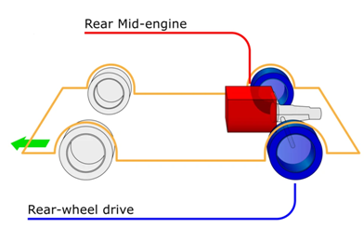In modern racing cars, **Rear Mid Engine** is the usual configuration and is usually synonymous with "mid engine". Due to its favorable weight dynamics, this layout is heavily employed in Formula racing cars (such as Formula One).

**Advantages :**

1. Good acceleration because of back weight transfer.

2. Efficient braking.

3. Neutral handling.

**Disadvantages :**

1. When accelerating some steering is lost.

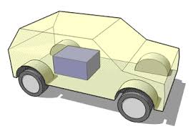2. Require more space.

3. No back seats.

4. Difficulties with the cooling system.

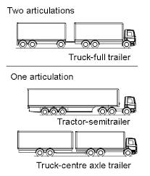**6)Articulated Vehicles :** These vehicles having a detachable trailer supported on a platform on the tractor unit are used to carry heavy loads which must not exceed gross train weight. The trailer tractor connection is also called the fifth wheel. It maximum permitted laden length and weight is 15 meters and 20 tonnes or less than four wheel vehicle. No time will be waste in loading or unloading as several trailers are available.

**7) Heavy Commercial Vehicles :**

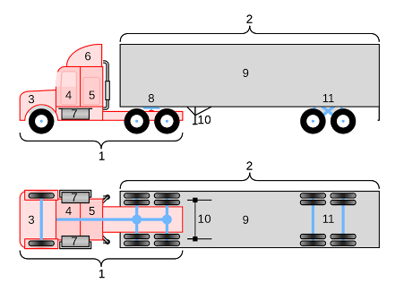These heavy and robust vehicles used for haulage purpose are powered by a diesel engine. Its gross vehicle weight (g.v.w.) is more than 3 tones. It required twin tyres fitted side by side on the rear wheels for carrying heavy loads. Sometimes, more axles are added for very heavy loads. All the power and transmission components are arranged in a driver compartment. Depending upon the requirement they may be open or closed body. The open body vehicles are known as light truck or pick up.